Lucas Swanson
5/05/2025
Software Engineering Methods
Exercise 5.4 (Reflection)
- One issue that both my team and myself found would be in the HTML, most of us pointed out the issues with the empty definition of the onClick=”” behavior, which should not be empty. If the logic is handled elsewhere, then do not list the onClick field at all, otherwise you can put the functional behavior here.
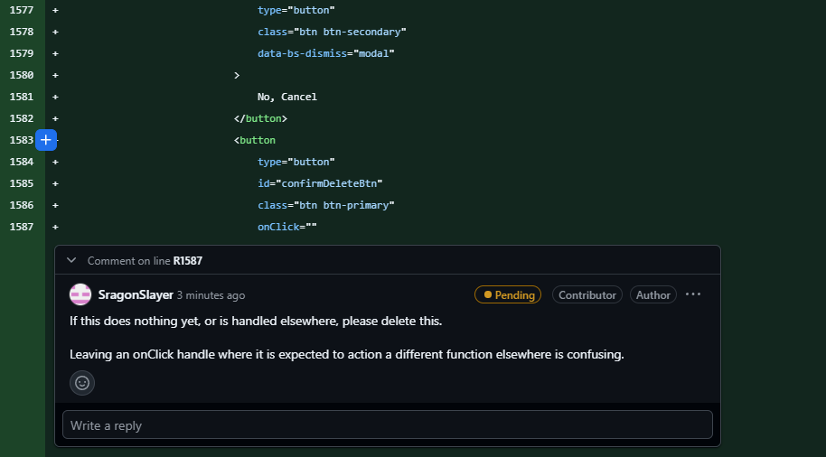
- On issue I identified that my team missed was the rounds subtracting one from the length when displaying the number of items displayed in the rounds tab. This should be equal to the length of the GlobalRoundsTable.rows.length.
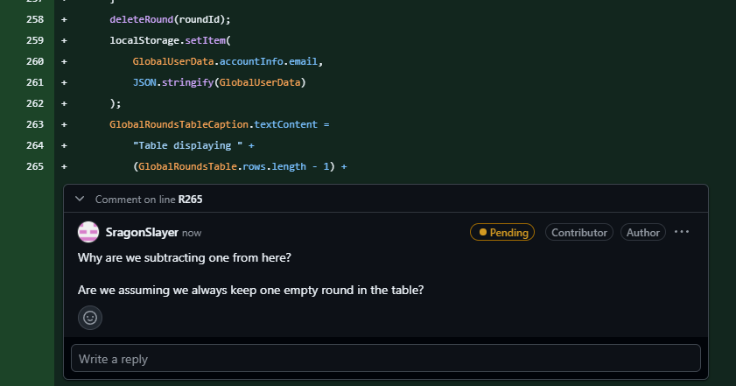
- I missed an issue inside the comments for the “deleteRound” function inside roundMode.js. I pointed out that the return comment was incorrect, but the function statement was completely wrong because the baseline functionality did not originally delete items from the local storage, this logic was instead inside the “confirmDelete” method, which goes against the descriptive comments.
